Chapter 4

Forecasting Demand

**Background**

This chapter contains a lot of formulas and forecasting techniques. Depending upon preferences, instructors would typically either cover the whole thing or just cover the “basics.” The basics would likely consist of the qualitative techniques; the time series techniques of simple moving average, weighted moving average, and simple exponential smoothing; and the forecast error measurements of MAD, MSE, and possibly MAPE. Keep in mind that it is possible to present linear regression without worrying about the formulas. Excel not only can easily perform a regression analysis, but the Excel commands “SLOPE”, “INTERCEPT’, and “FORECAST” can be used to immediately calculate a single linear regression without even invoking the data analysis tool. Whichever set of techniques are presented, it is important to emphasize to the students the crucial need for accurate forecasts and how so many company decisions are driven by forecasted numbers.

**Class Discussion Ideas**

1. Forecasting drives many other OM decisions. Having the students create a list of decisions that require some sort of forecast can help make this point quite clear.

2. NCAA college football rankings represent, in some sense, a forecast of the relative likelihood of success of the top 25 teams in the country. Ask the students to identify the components that likely most influence the voter polls, as well as the actual components that make up the computer-based BCS rankings (most college classes will have at least some students who are very knowledgeable about the BCS system). Have the students discuss the pros and cons of the subjective voter rankings (forecasts) vs. the more objective computer BCS rankings (forecasts). Instructors could even provide data for, say, the past five seasons, on how well the initial BCS rankings predicted the big five bowl winners vs. the voter polls that came out in the same week. (Note that there is definite correlation because the voter polls themselves make up part of the BCS formula.)

3. Several research studies have suggested that, based on linear regression, the relationship between college entrance exam scores and grade point average in college is generally weak. (Similar claims can be made about GMAT scores and grade point averages in MBA schools.) Yet these exams are extensively used. Why? Discussion will likely generate several different reasons. (Note the related homework problem 4.46.)

**Active Classroom Learning Exercises**

1. One effective way to develop an appreciation for the causal nature of associative forecasting is to have the students split into small groups and develop a list of 10 or so associative relationships specific businesses might use in their forecasting models and why these models would be preferred to time series models. Have each student group report its ideas to the whole class.

2. Banks and fast food outlets are among the richest sources of seasonality components. Demand varies by the hour, by the day of the week, by the day of the month, by the week of the month, and by the month of the year. Have the students split into small groups and assign a local business to each group. Ask the students to identify as many seasonality components as they can. Have each student group report its ideas to the whole class.

**Company Videos**

1. *Forecasting at Hard Rock Cafe (8:08)*

Hard Rock Cafe uses moving averages, weighted moving averages, exponential smoothing, and regression analysis for forecasting. Sales forecasts drive many short-term and long-term decisions within the company, including long-term purchasing commitments and cash flow forecasts for borrowing needs. Forecast variances are computed, and root causes of those variances are sought out whenever the variances are too high. Counting the number of people that come through the door, and knowing how many ordered menu items vs. other things, drives the sales forecast. Point-of-sale registers at each restaurant provide that information to the corporate office. The weighted moving average forecasting technique is used to set sales and bonus targets for store managers. The most interesting forecasting application discussed is the use of multiple regression analysis for menu items. Managers can estimate the price elasticity of demand for each menu item, and they can accurately estimate the impact of a price increase for one item on the demand for other items on the menu. This video nicely drives home the idea that forecasts drive most decisions in a company, implying that proper forecasting is crucial.

Prior to showing the video, the instructor might ask the students to identify the decisions at Hard Rock that are based on sales forecasts. Follow-up discussion could identify the ones mentioned in the video and brainstorm about others as well. An alternative discussion could have students identify driving factors that might cause forecasts to differ in different locations (for example, demographics, tourist traffic, economic health, local eating habits, etc.).

**Cinematic Ticklers**

1. *The Simpsons, Season 13: “Treehouse of Horror XII,” FOX, 2001*

In the first segment of this Halloween special, the Simpsons visit a fortune teller, and Homer destroys her office. She asks, “Why didn’t I see this coming?,” as she notices a fortune-telling card with a picture of Homer being destructive on it. She curses Homer, and Marge wakes up with a long beard the next morning.

2. *Saturday Night Live, Season 32, Episode 16 (Guest Host: Peyton Manning): “ESPN’s NCAA Tournament Pool Party,” NBC, March 24, 2007*

Peyton Manning plans a sports enthusiast who has performed well in the ESPN NCAA basketball tournament pool after opening weekend. He is losing, however, to Mandy (played by Amy Poehler), who knows absolutely nothing about sports. She picks winners based on their names, their mascots, and other crazy reasons. Peyton Manning’s character gets increasingly flustered during the skit, particularly when the MC and Mandy make reference to “pulling a Peyton Manning” (which refers to all the years when Manning had great statistics during the regular season but then his NFL team lost in the playoffs).

**Presentation Slides**

INTRODUCTION (4-1 through 4-13)

Slides 10-13: The Global Company Profile for this chapter is Disney World, a place that many students will have visited or have wanted to visit. Disney has one of the more intricate forecasting systems in the world. The firm looks not only at historical data, but also a slew of inputs including vacation schedules of public schools, exchange rates, GDP data, and airline specials. The one-year forecasts are amazingly accurate. Such accuracy is crucial, as the forecasts drive many different management decisions, including park hours, number of characters to distribute, amount of food to buy, number of shows to put on, etc.



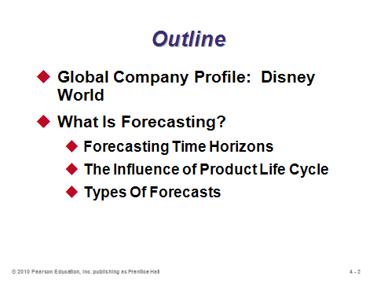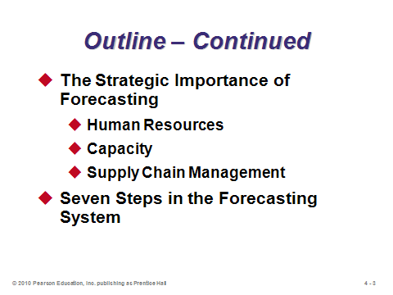

**4-1 4-2 4-3**

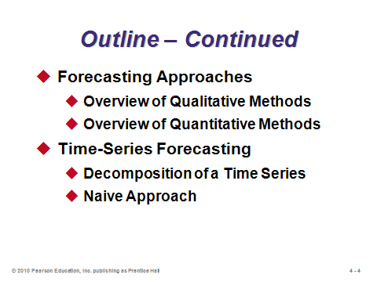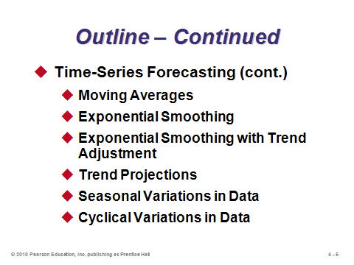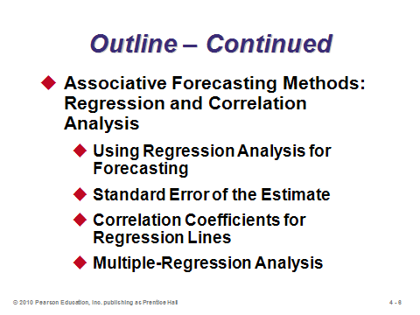

**4-4 4-5 4-6**

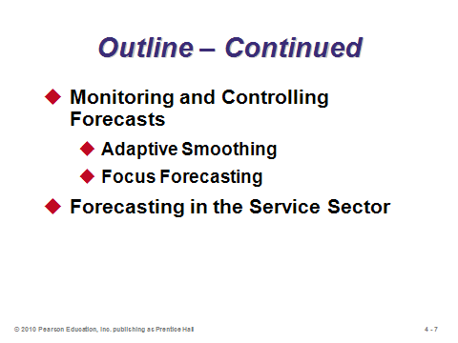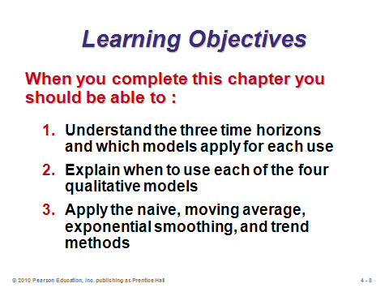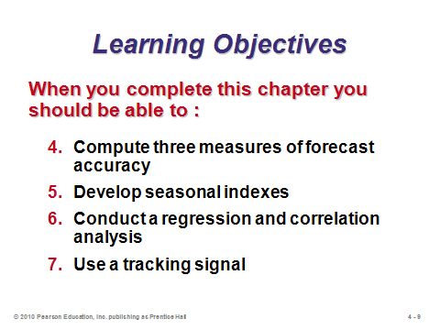

**4-7 4-8 4-9**

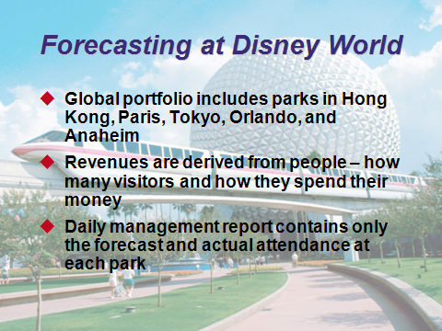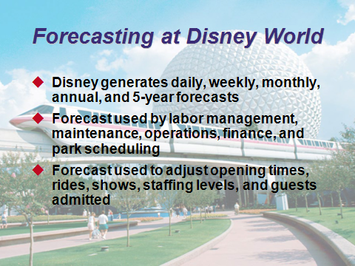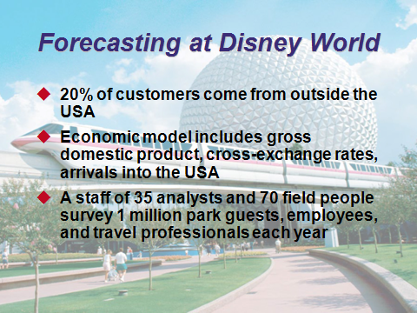

**4-10 4-11 4-12**

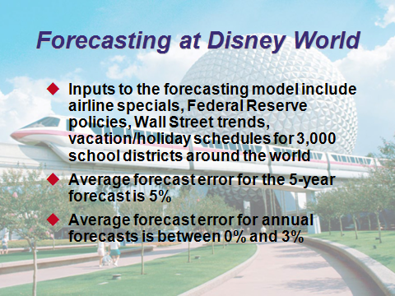

**4-13**

WHAT IS FORECASTING? (4-14 through 4-20)

Slide 14: Whether for gambling, deciding how thick of a coat to wear, or determining which career would be most interesting and lucrative, we all make or use forecasts regularly. All business decisions are ultimately driven by forecasts of the future. Thus, a poor forecast will likely lead to a poor decision, even if the decision methodology is sound (like “garbage-in, garbage-out” (GIGO) in computer programming).

Slides 15-16: These slides describe and differentiate the three categories of forecasting horizons. Clearly, forecasts from different horizons have different applications.

Slides 17-19: Students should be familiar with the product life cycle from Chapter 2. In fact, Slides 18 and 19 replicate Figure 2.5 from that chapter. Accurate forecasting for each stage is crucial for making quality decisions about the inevitable changes that must be made as a product moves through its life cycle.

Slide 20: Organizations use the three major types of forecasts identified in this slide for planning future operations. The operations manager typically focuses on demand forecasts.

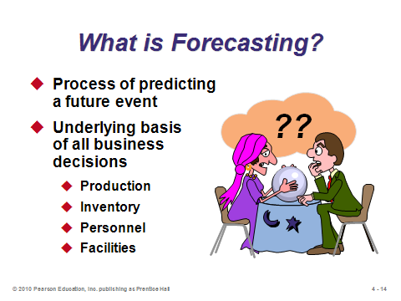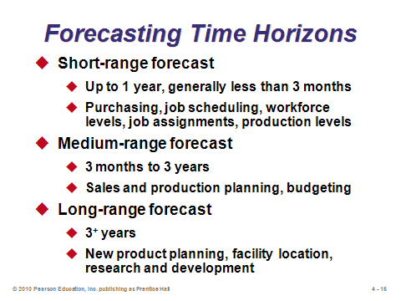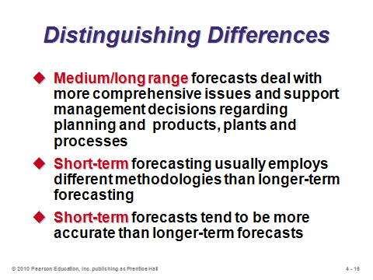

**4-14 4-15 4-16**

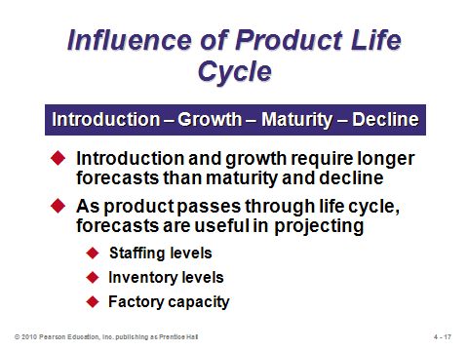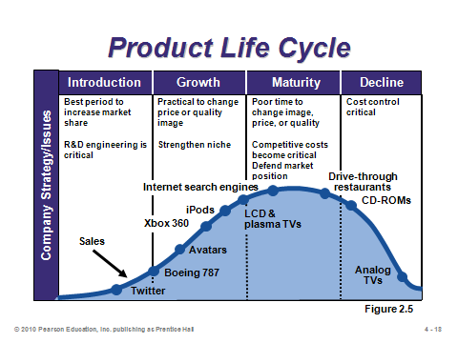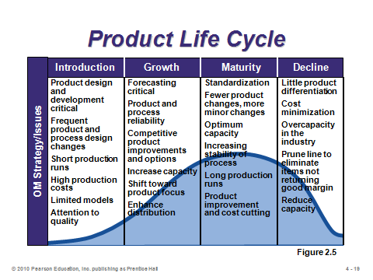

**4-17 4-18 4-19**

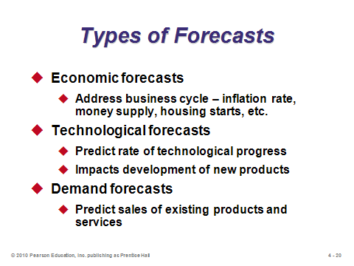

**4-20**

THE STRATEGIC IMPORTANCE OF FORECASTING (4-21)

Slide 21: Demand forecasts drive decisions in many areas, including the three described in this slide. For example, firms typically do not hire more workers when demand is falling, and vice-versa.

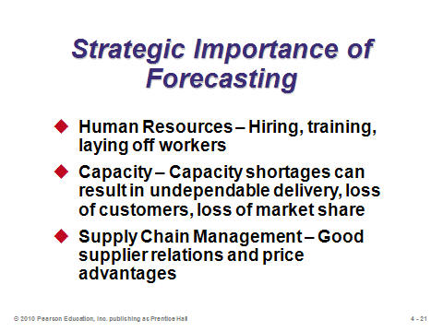

**4-21**

SEVEN STEPS IN THE FORECASTING SYSTEM (4-22 through 4-23)

Slide 22: The seven steps in forecasting are presented in this slide. The text uses Disney World as an example of each step. Instructors could use that firm or choose one of their own. They could even pick an organization (possibly on campus) and have students try to describe how the organization might implement each step.

Slide 23: Every company must contend with several realities about forecasting, including those described on this slide. Forecasts need to be closely monitored to identify, for example, unusual circumstances or major shifts from historical trends. Also, when decisions can be based on aggregated rather than individual product forecasts, the aggregated forecasts should be used.

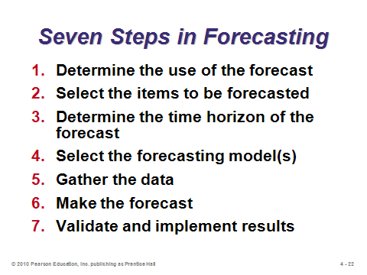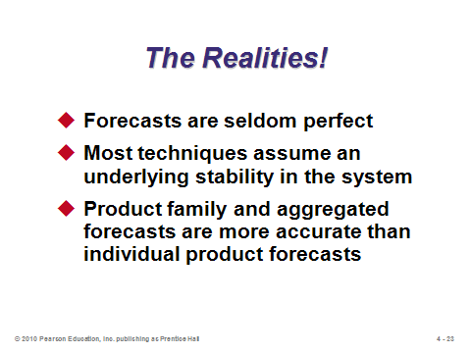

**4-22 4-23**

FORECASTING APPROACHES (4-24 through 4-32)

Slides 24-25: These slides compare when to use qualitative methods vs. quantitative methods. Sometimes a combination of both would be appropriate, particularly to incorporate new phenomena that were not part of the historical data.

Slides 26-31: Slides 26 and 27 identify the four primary qualitative forecasting methods, which are described further in the following four slides. Slide 30: An analogy that might help students understand the Delphi method is the college football coaches’ poll. At the beginning of the season, each voting coach submits his rankings of the top 25 football teams in the nation (essentially a forecast for which teams will do the best). Most likely, however, he will be familiar with only a subset of teams: schools from his region and perhaps some nationally ranked schools from the previous season that did not graduate many seniors. After the first poll comes out, other schools may be ranked of which he was not aware. After studying those teams, the coach may be convinced during the following week’s poll to vote for some of them. Over the season, the poll is dynamic as teams win and lose; nevertheless, information provided from other experts (other voting coaches) does add information that may alter a coach’s forecast the next time around.

Slide 32: This slide identifies the quantitative forecasting methods described in this chapter.

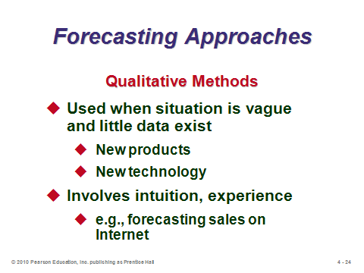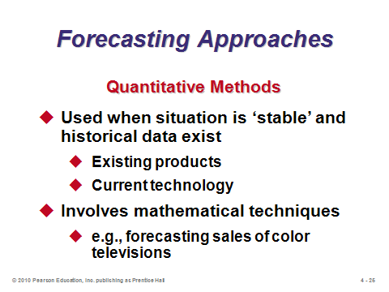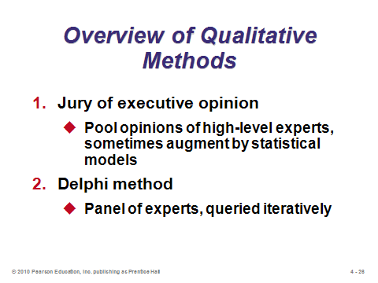

**4-24 4-25 4-26**

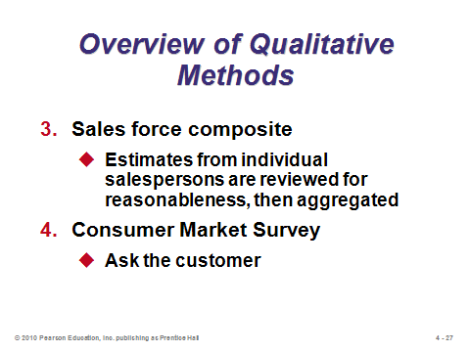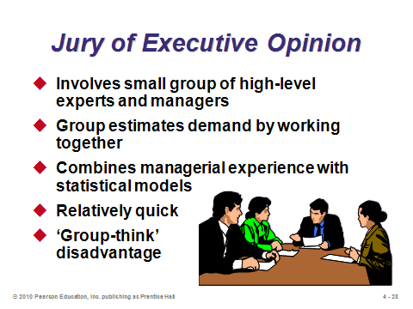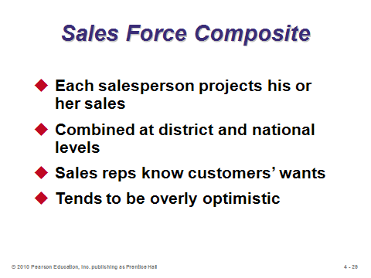

**4-27 4-28 4-29**

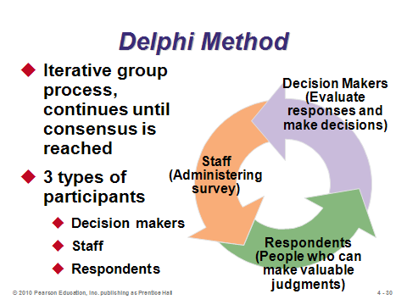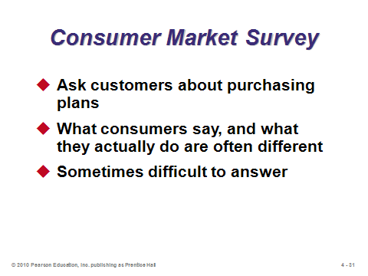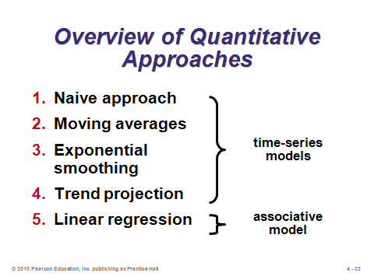

**4-30 4-31 4-32**

TIME-SERIES FORECASTING (4-33 through 4-89)

Introductory Paragraph (4-33)

Slide 33: This slide describes the basic assumptions of time series forecasting.

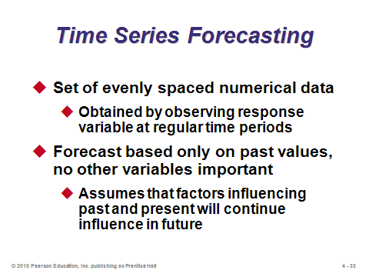

**4-33**

Decomposition of a Time Series (4-34 through 4-39)

Slides 34-39: Slide 34 identifies the four components of time series forecasting. Slide 35 (Figure 4.1) illustrates trend, seasonality, and random variation as compared to the average demand over that four-year time period. Slides 36-39 describe each of the four components in more detail.

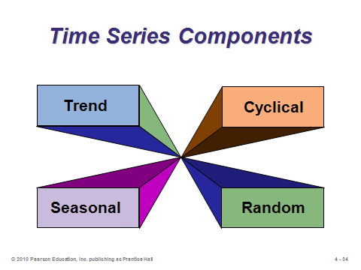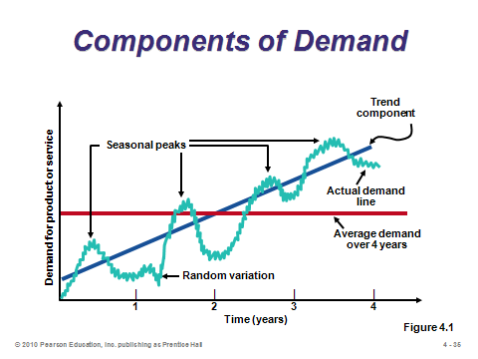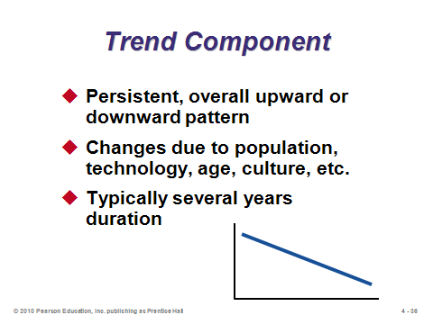

**4-34 4-35 4-36**

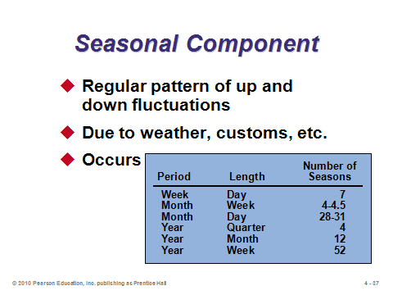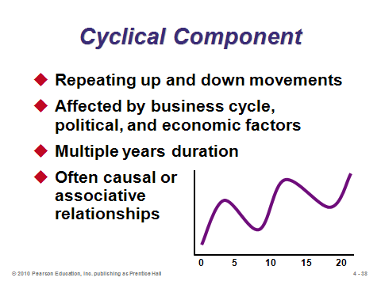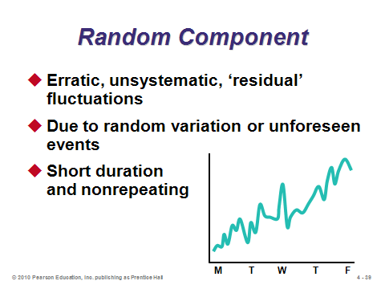

**4-37 4-38 4-39**

Naive Approach (4-40)

Slide 40: The naive approach is so simple that it could be considered to be a qualitative forecasting method. Numerous forecasts in the real world are made this way, especially for infrequent events. For example, with no additional information available, it would make sense to forecast attendance at this year’s sorority spring dance to be the same as last year’s.

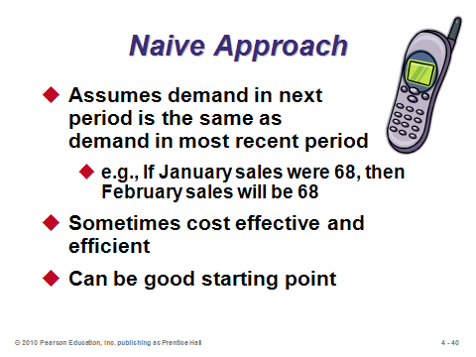

**4-40**

Moving Averages (4-41 through 4-47)

Slides 41-43: Slide 41 provides information about, and the formula for, the simple moving average forecast. It is applicable if we can assume that market demands will stay fairly steady over time. It can help to smooth out random fluctuations. Slide 42 provides a snapshot from Example 1 in the text. Each month, demand from the oldest month is discarded and replaced with the newest actual demand. Slide 43: If there are changes in demand, moving average forecasts will lag behind actual demand, as this slide illustrates.

Slides 44-45: Slide 44 provides information about, and the formula for, the weighted moving average forecast. While this method still lags behind trends, it does a better job of catching them sooner that the simple moving average method does. The weights often sum to 100%, effectively eliminating the denominator in the formula. In fact, even when the weights sum to something else, students often forget to divide by that number. If significant seasonality exists, the weighted moving average could be a crude way to incorporate it by applying the largest weight to demand from that season’s last appearance. Slide 45 provides a snapshot from Example 2 in the text. Like the simple moving average case, the oldest data is replaced with the newest each month. In addition, all of the old data are moved back a month and have potentially different weights applied to them (often becoming smaller as in this example).

Slide 46: This slide identifies some potential downsides of using moving average forecasts.

Slide 47: This slide (Figure 4.2) augments slide 43 by adding the weighted moving average forecast from Example 2 in the text. This forecast also lags behind actual sales when a trend exists, but reacts slightly quicker.

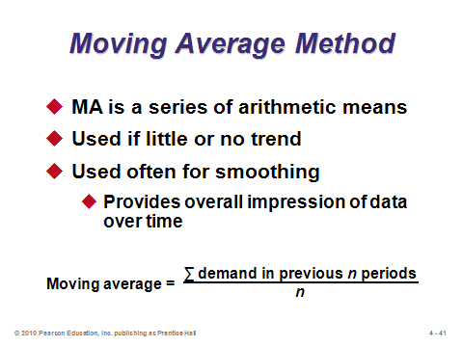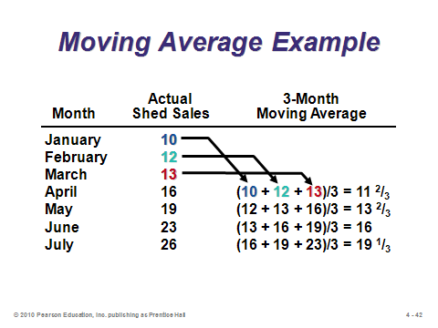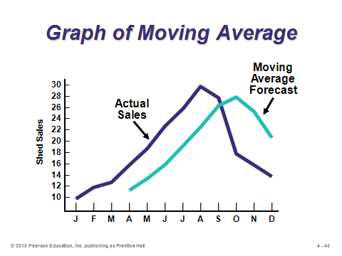

**4-41 4-42 4-43**

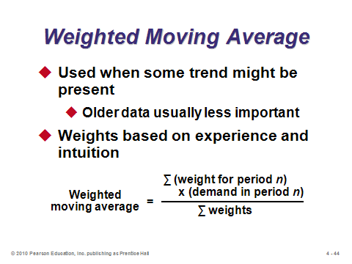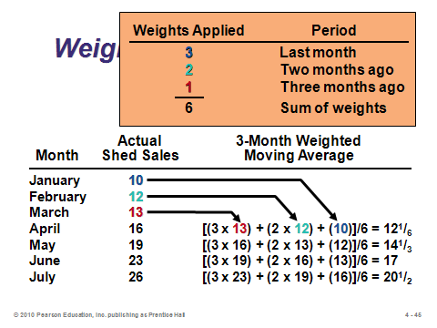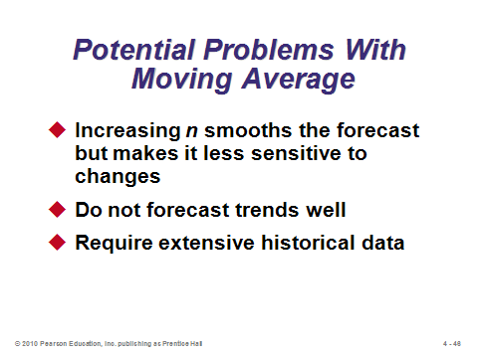

**4-44 4-45 4-46**

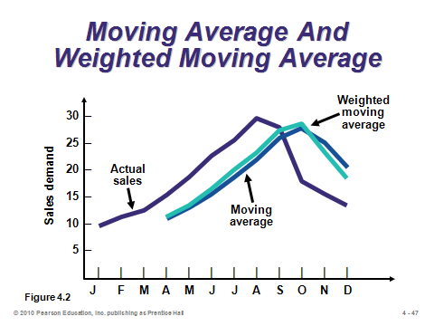

**4-47**

Exponential Smoothing (4-48 through 4-56)

Slides 48-49: Slide 48 describes the characteristics of the exponential smoothing forecasting method. Even though it is a form of weighted moving average, the special recursive formula means that less record keeping is necessary than for a regular weighted moving average forecast. If the weights are plotted on a graph, the curve drawn over them will be exponential in shape (hence the name). All old data remains part of the forecast, but the weights applied to very old data are extremely small. Slide 49 provides the formula. The only data needed are last period’s actual and forecasted demands. The method adjusts the forecast each period by a certain percentage (α) of the error in the previous period’s forecast. If the previous forecast was 40 units too high and α = 20%, then the new forecast will be 8 units (.20 × 40) lower.

Slides 50-52: Theses slides present Example 3 from the text. Here the new forecast was slightly higher because the previous forecast underestimated the true demand.

Slides 53-56: These slides examine the effect of the smoothing constant α. Note that there is no “optimal” value of α, and it should possibly be altered over time. Slide 53 shows that a high value of α places much more weight on the very recent periods, so the forecast can react much quicker to trends (displayed in Slide 54). In fact, when α = 1, exponential smoothing becomes the naive approach (this can be a good test question). In other words, the forecast is adjusted by the full error in the previous period’s forecast. When α = 0, the forecast never changes (note that this is *not* the naive approach). A good way to choose α is to test different values on old data (Slide 56). Whichever value yields the smallest errors might be a good choice for the future. Nevertheless, future conditions might change, so forecast accuracy should continue to be monitored and alpha values adjusted as needed over time.

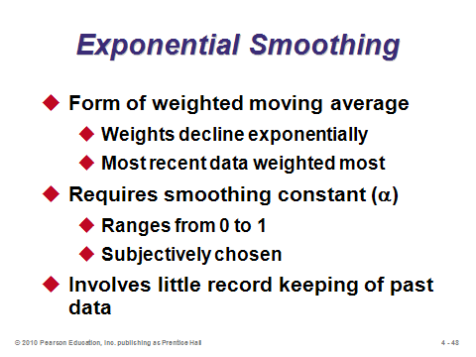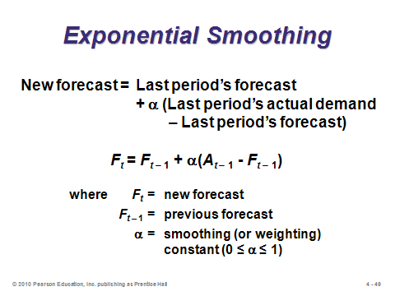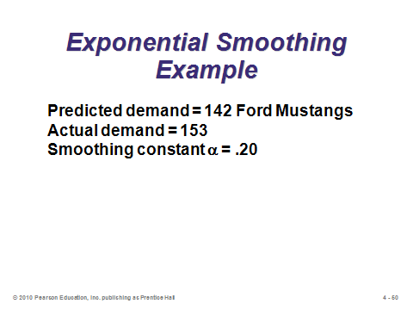

**4-48 4-49 4-50**

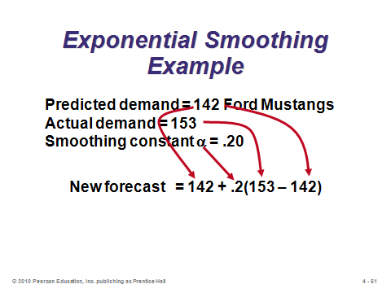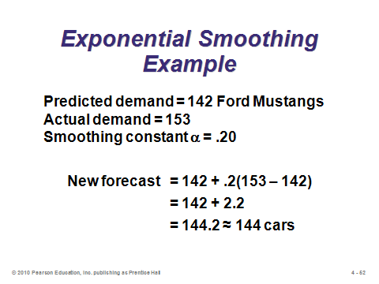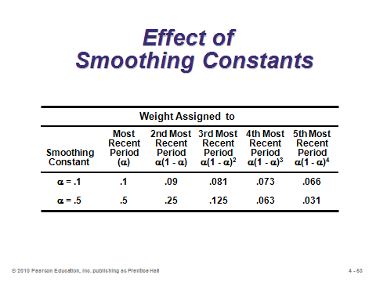

**4-51 4-52 4-53**

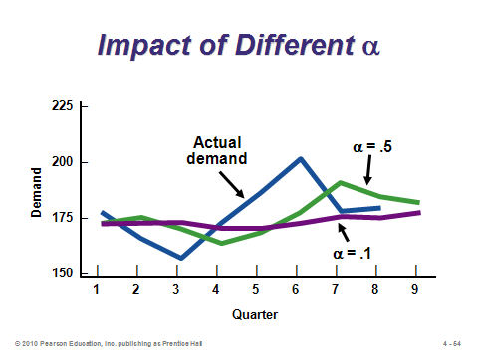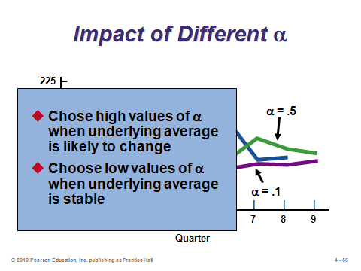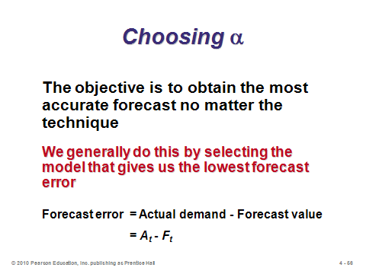

**4-54 4-55 4-56**

Measuring Forecast Error (4-57 through 4-63)

Slides 57-58: These slides present the formulas for the three most common measures of forecast error. Note that “mean error” (without taking the absolute values) would not be proper because positive errors would cancel out negative errors, suggesting better performance than actually occurred. Mean squared error is appropriate for protecting against particularly poor forecasts in any period, if that is of concern. Mean absolute percent error has the advantage of defining errors in percentage terms, which can be easier to grasp than the large numbers produced by MAD and MSE. Note that the three measures do not always identify the same method as being the best.

Slides 59-63: These slides (Examples 4, 5, and 6) compare forecasts using two different values of α by calculating MAD, MSE, and MAPE. For this example, the lower value of α (.10) performed best under all three measures.

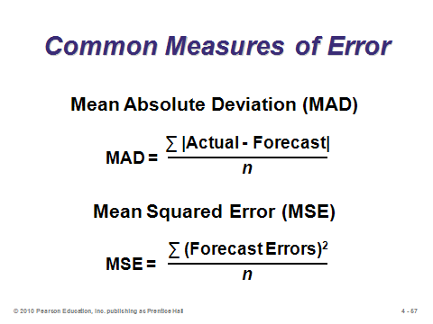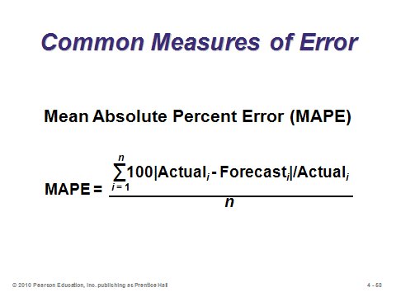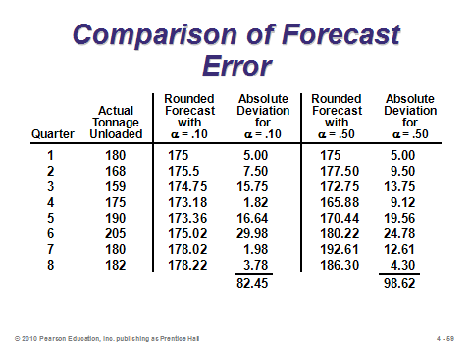

**4-57 4-58 4-59**

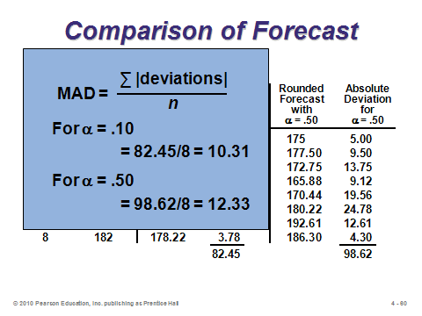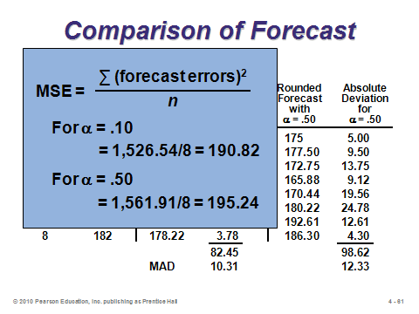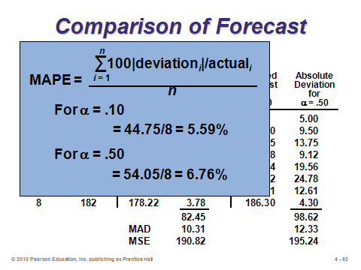

**4-60 4-61 4-62**

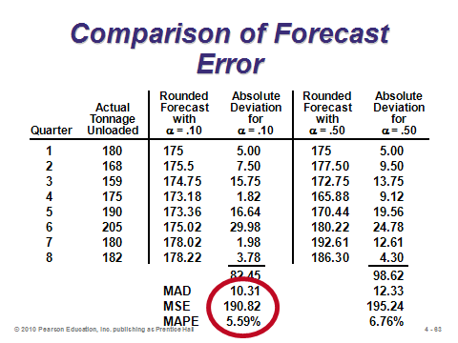

**4-63**

Exponential Smoothing with Trend Adjustment (4-64 through 4-71)

Slides 64-65: Exponential smoothing with trend adjustment is also called “double exponential smoothing” or “Holt’s method.” If it is known that a trend exists (for example, demand is rising or falling), this method can react more quickly than single exponential smoothing can. Slide 64 shows that the overall forecast is based on two pieces, a level (underlying) forecast and a forecast of the trend. Note that the forecast for *n* periods in the future would be *Ft* + *nTt*. Slide 65 presents the formulas for the two pieces of the overall forecast, where β (also a fraction) is a separate smoothing constant from α that is applicable to the trend component of the model.

Slides 66-71: These slides present Example 7 from the text. The graph in Slide 71 (Figure 4.3) shows that this method can pick up the trend in actual demand very quickly.

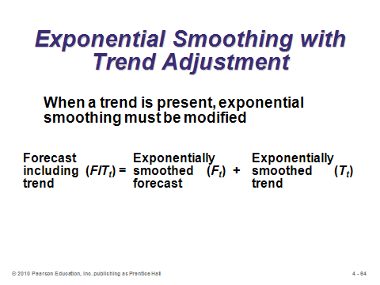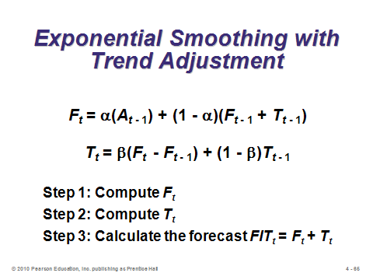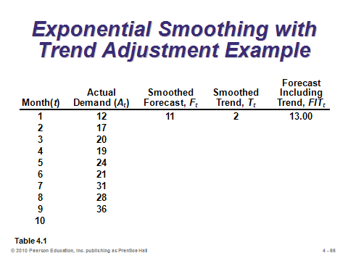

**4-64 4-65 4-66**

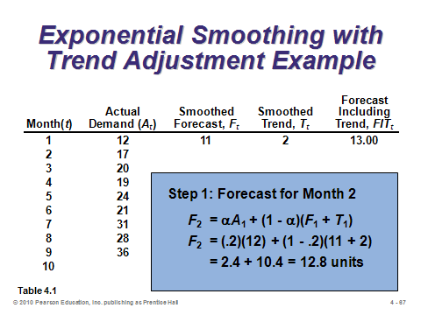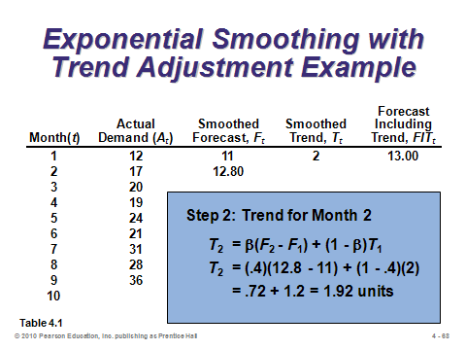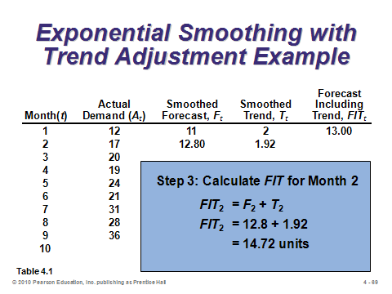

**4-67 4-68 4-69**

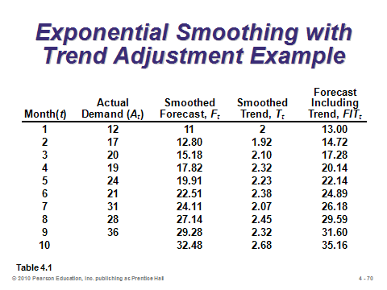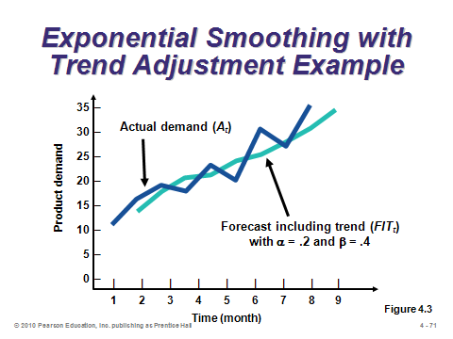

**4-70 4-71**

Trend Projections (4-72 through 4-79)

Slide 72: This slide presents the concept of a trend projection. The assumption is that the general trend seen in the past will continue into the future in a linear fashion. This method may be useful in making medium- to long-range forecasts. Least squares regression can be used to calculate the values for the equation.

Slides 73-75: Slides 73 (Figure 4.4) and 74 illustrate the concept behind the least squares method. Slide 75 provides the formulas for the slope and intercept terms.

Slides 76-78: These slides present Example 8 from the text. Alternatively, these calculations can be performed in Excel using the SLOPE and INTERCEPT functions. For example, put the numbers 1 through 7 in cells A1 through A7 respectively. Then insert the associated demands for those time periods in cells B1 through B7. The Excel formula **=SLOPE(B1:B7,A1:A7)** will compute the value of *b*, and the formula **=INTERCEPT(B1:B7,A1:A7)** will compute the value of *a*.

Slide 79: This slide identifies important requirements that must be met in order to effectively utilize the least squares trend projection method. In particular, the observations themselves should be rising or falling approximately linearly, and the deviations from the line should be approximately normally distributed, with most observations close to the line and only a small number farther out. And at some point in the future this linear growth will change slope or shape, so forecasts should not be made too far ahead.

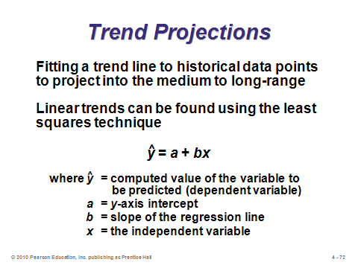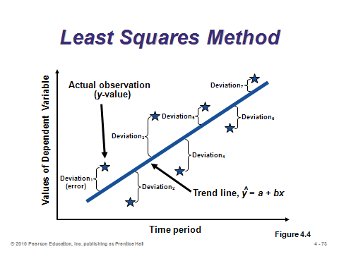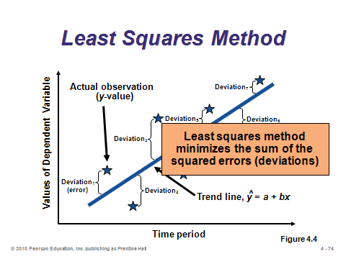

**4-72 4-73 4-74**

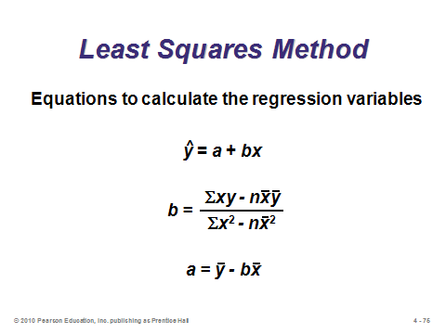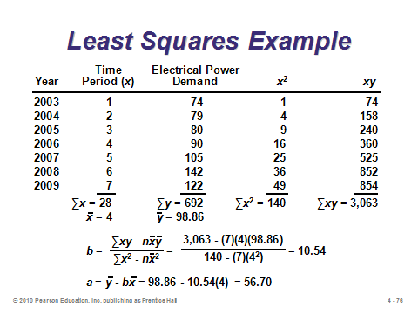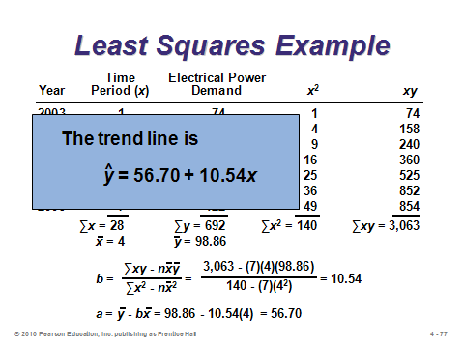

**4-75 4-76 4-77**

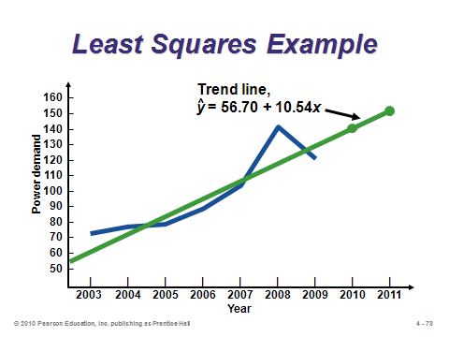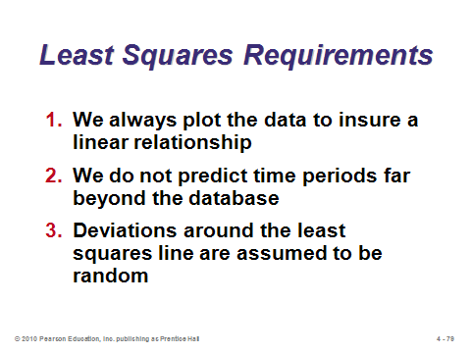

**4-78 4-79**

Seasonal Variations in Data (4-80 through 4-89)

Slides 80-81: Seasonal demand is common in many industries, so the associated forecasts should be adjusted to account for this major impact. Slide 81 identifies the steps for the *multiplicative seasonal model*. (The steps are not so obvious at first glance, so the follow-up example should definitely be presented to students.) Instructors might note that an alternative method for incorporating seasonality is to include it within an exponential smoothing framework. This is called “triple exponential smoothing,” or “Winter’s method,” and it introduces a third smoothing constant γ.

Slides 82-86: These slides present Example 9 from the text. In Slide 82, the fifth column calculates an average demand for each season (month), and the average monthly demand in the sixth column equals the total average annual demand (the sum of column 5) divided by 12 months. Slides 83 and 84 show how to calculate the seasonal index for each month. In Slide 85, we start with a forecast for the whole year 2010. This annual forecast is divided among the months by converting it into an average monthly forecast and multiplying that by the applicable seasonal index for each month. Slide 86 graphs the three years of actual demands as well as the demand forecasts for 2010.

Slides 87-89: These slides present Example 10 from the text, which shows a way to incorporate both trend and seasonality into the same forecast. A trend line (least squares) is first created (Slide 87). Then seasonal indices are computed based on the same data (Slide 88). Finally, the trend-adjusted forecasts are multiplied by the associated monthly seasonal indices to produce the combined forecasts (Slide 89).

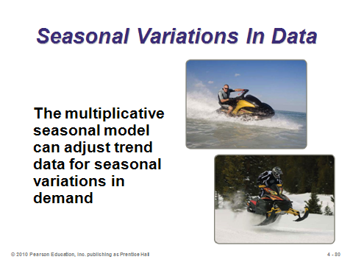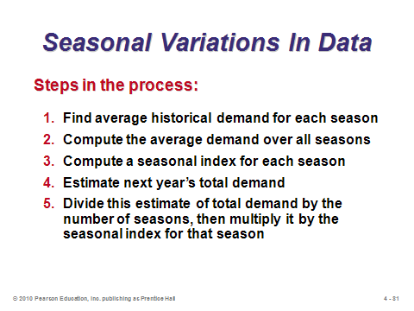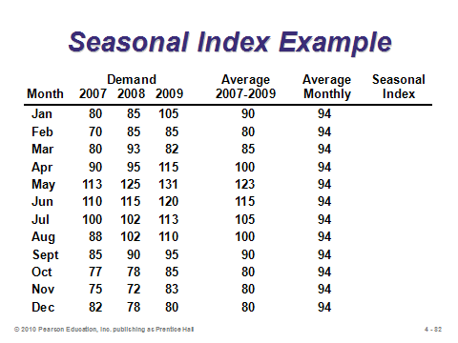

**4-80 4-81 4-82**

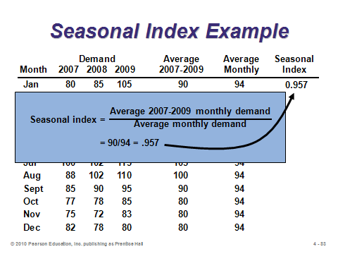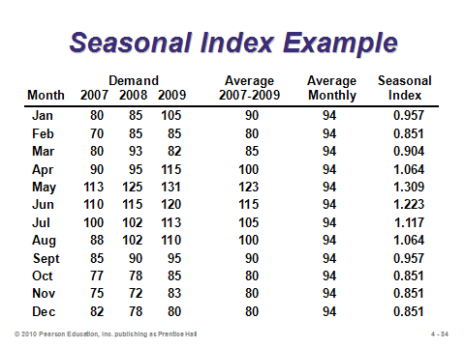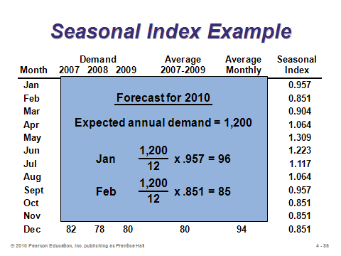

**4-83 4-84 4-85**

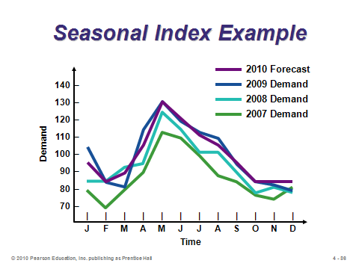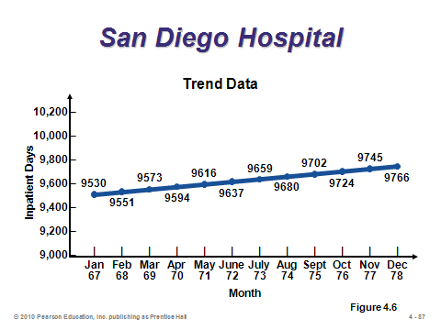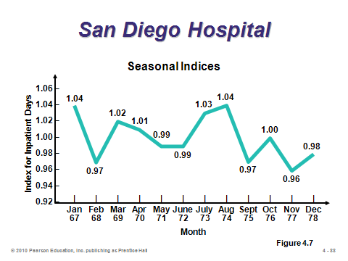

**4-86 4-87 4-88**

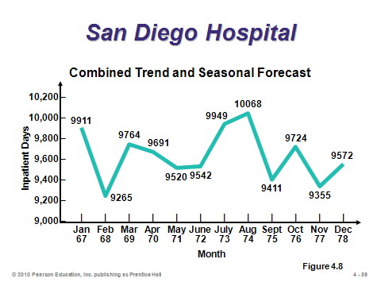

**4-89**

ASSOCIATIVE FORECASTING METHODS: REGRESSION AND CORRELATION ANALYSIS (4-90 through 4-104)

Slides 90-91: As opposed to basing forecasts on patterns of historical data, associative forecasting estimates the impact of certain predictors (independent variables) on the outcome (dependent variable). Predictors could include items such as the gross domestic product of the country, the level of advertising applied to a certain product, the weather for an outdoor event, etc. Simple linear regression assumes one independent variable and is the exact same technique as that used for time series trend projections. Slide 91 presents the formula.

Slides 92-94: These slides present Example 12 from the text, which assumes that sales volume is highly dependent upon payroll levels in the area. Slide 92 presents the raw data, and Slide 93 presents the calculations. Slide 94 plots the regression line and shows how to make a forecast based on a particular independent variable value ($6 billion). Similar to the description for Slides 76-78 above, Excel’s SLOPE and INTERCEPT functions can be used to automate the calculations.

Slides 95-97: The *standard error of the estimate* is a measure of variability around the regression line—its standard deviation. The formula in Slide 97 is the easier of the two to use.

Slide 98: This slide (Example 13) computes the standard error of the estimate for the regression line of Slide 94 (Example 12). The interpretation of the standard error of the estimate is similar to the standard deviation; namely, 1 standard deviation = .6827. So, in this example, there is a 68.27% chance of sales being within $306,000 from the point estimate of $3,250,000.

Slides 99-101: Slide 99 describes the concept of correlation, and Slide 100 presents the formula for the correlation coefficient. Slide 101 (Figure 4.10) presents a nice graphical demonstration of the concept of correlation.

Slide 102: This slide describes the concept of coefficient of determination (*r*2). Example 14 in the text presents the calculations for correlation. The result and the corresponding coefficient of determination are displayed at the bottom of this slide.

Slides 103-104: Slide 103 introduces the notion of *multiple* regression analysis (more than one independent variable). Slide 104 presents the results from Example 15 in the text (solved via computer).

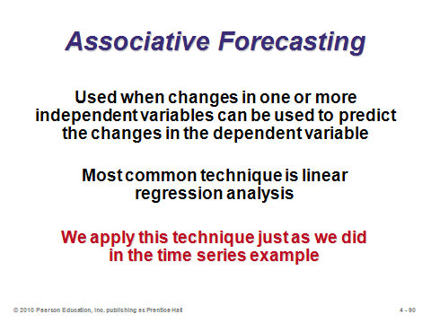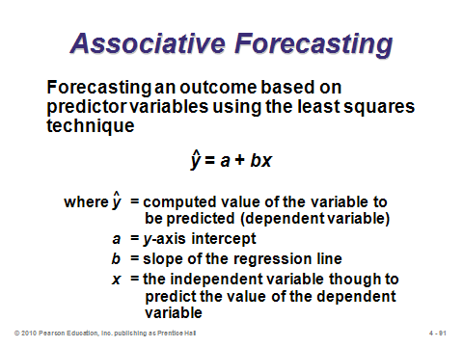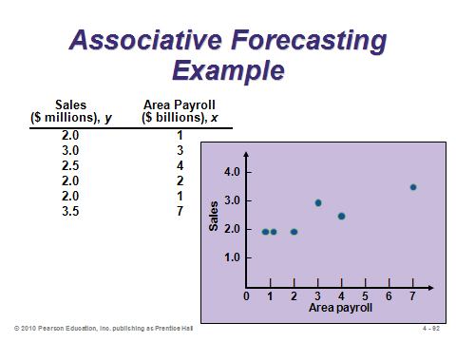

**4-90 4-91 4-92**

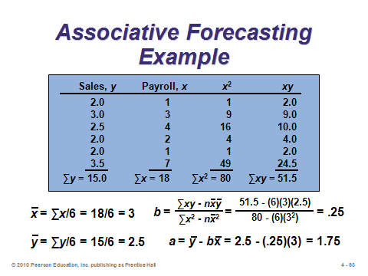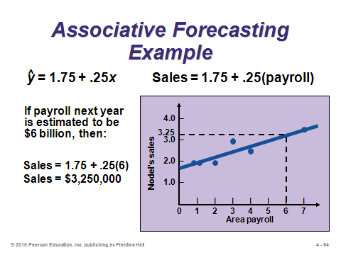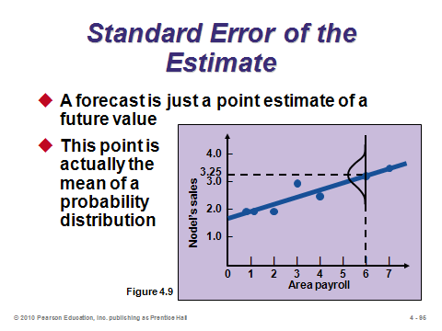

**4-93 4-94 4-95**

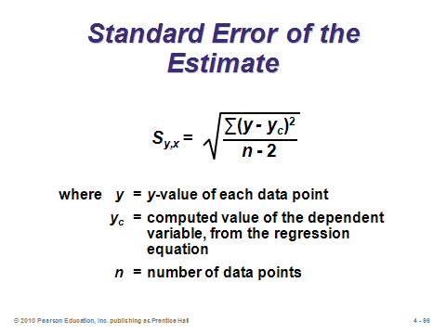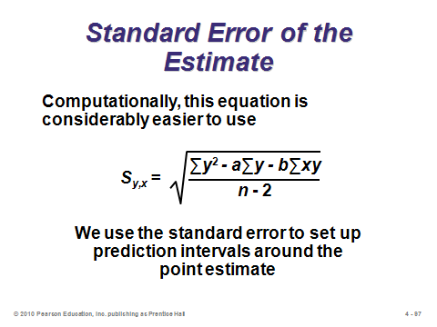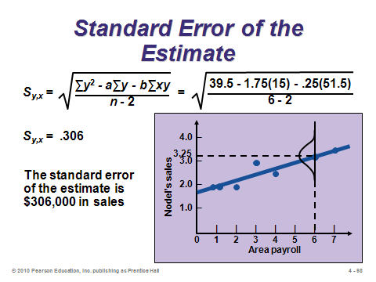

**4-96 4-97 4-98**

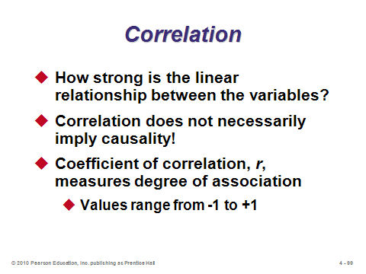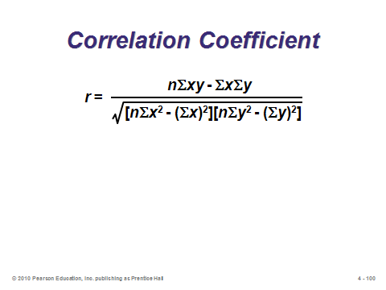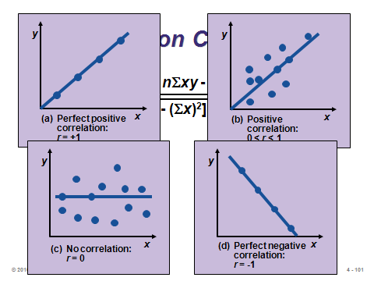

**4-99 4-100 4-101**

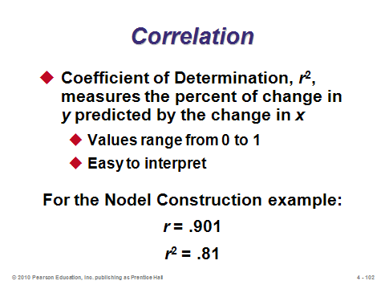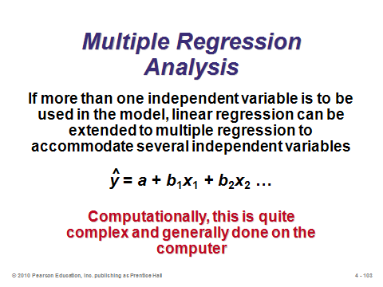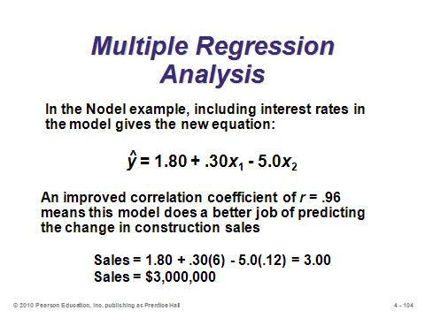

**4-102 4-103 4-104**

MONITORING AND CONTROLLING FORECASTS (4-105 through 4-111)

Slides 105-107: Slide 105 introduces the notion of a tracking signal, which is a good way to make sure that the forecasting system is doing a good job. Slide 106 presents the formula. Slide 107 (Figure 4.11) illustrates the concept. If the tracking signal falls outside of the predetermined upper and lower control limits, the forecasting method should be examined for possible adjustment.

Slides 108-109: These slides present Example 16 from the text. Management is using control limits of 4 MADs, so the variation is deemed acceptable.

Slide 110: These slides introduce the concepts of *adaptive forecasting* (Slide 110) and *focus forecasting* (Slide 111), both of which includes an artificial intelligence component.

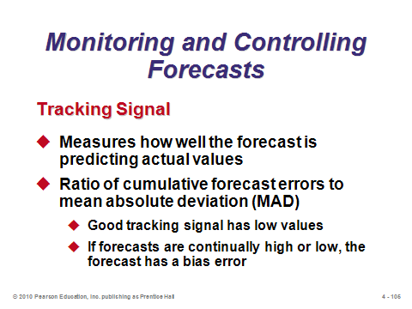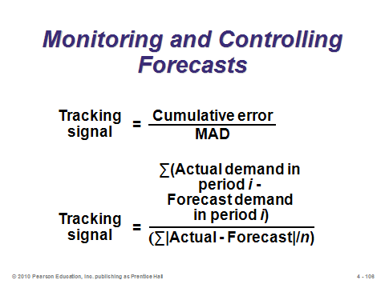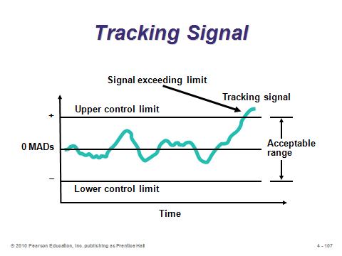

**4-105 4-106 4-107**

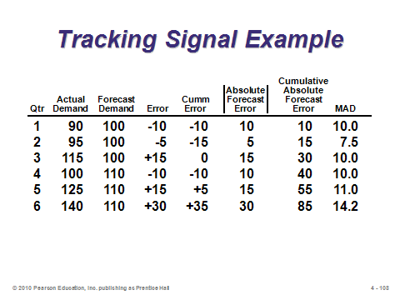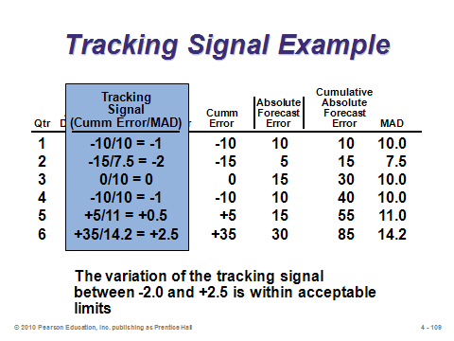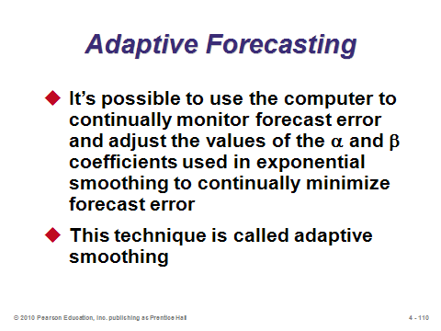

**4-108 4-109 4-110**

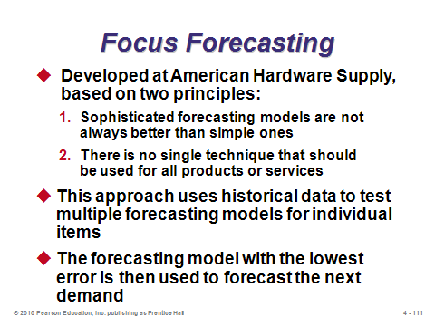

**4-111**

FORECASTING IN THE SERVICE SECTOR (4-112 through 4-114)

Slide 112: This slide identifies some of the unusual challenges faced when attempting to forecast in the service sector.

Slides 113-114: These slides (Figure 4.12) show the tremendous *hourly* variation in demand present at many typical services.

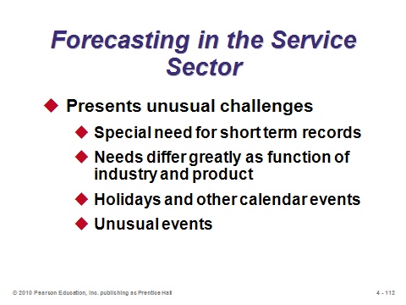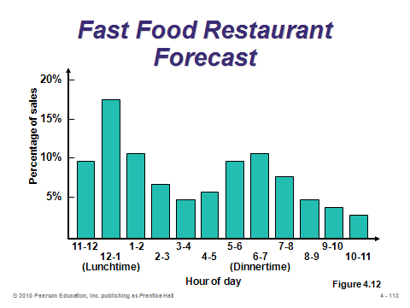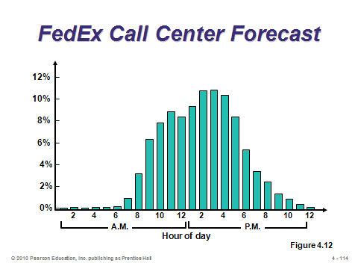

**4-112 4-113 4-114**

**Additional Assignment Ideas**

1. There are many different software products for forecasting. Find and visit the Web sites of a couple and describe the different tools used. Provide a sample screen capture that illustrates the graphical user interface. (Hint: search on the phrase: "operations forecast software".)

2. Interview an appropriate manager from a business in your home town. Describe the methods that they use for forecasting. What factors drive most of their forecasts?

**Additional Case Studies**

Internet Case Study (www.pearsonglobaleditions.com/heizer)

* *North-South Airline*: Reflects the merger of two airlines and addresses their maintenance costs.

Harvard Case Studies (http://harvardbusinessonline.hbsp.harvard.edu)

* *Merchandising at Nine West Retail Stores* (#698-098): This large retail shoe store chain faces a merchandizing decision.
* *New Technologies, New Markets: The Launch of Hong Kong Telecom's Video-on-Demand* (#HKU-011): Asks students to examine the forecasting behind a new technology.
* *Sport Obermeyer, Ltd*. (#695-022): This skiwear company has short life-cycle products with uncertain demand and a globally dispersed supply chain.
* *L. L. Bean, Inc*. (#893-003): L. L. Bean must forecast and manage thousands of inventory items sold through its catalogs.

Richard Ivey School of Business (http://cases.ivey.uwo.ca/cases/pages/home.aspx)

* *Wilkins, A Zurn Company: Demand Forecasting* (#9B06D006): The newly promoted inventory manager wonders if there is an easier, more reliable means of forecasting the sales demand. Currently forecasts are based on the plant manager, sales/marketing manager, and inventory manager's knowledge of industry trends, competitive strategies, and sales history.
* *Greaves Brewery: Bottle Replenishment* (#9B04D017): The purchasing manager was wondering how many bottles he should purchase in the coming year. Last year, the market had leveled off and sales predictions were difficult. On the one hand he wanted to be sure sufficient bottles were available to supply this year's sales levels, yet he also wanted to minimize year-end inventories as covered storage space for empty bottles was tight and a bottle change-over seemed possible in the next two years.

**Internet Resources**

|  |  |
| --- | --- |
| American Statistical Association | www.amstat.org |
| Institute for Business Forecasters | http://www.ibf.org |
| Journal of Time Series Analysis | www.blackwellpublishers.co.uk |
| Royal Statistical Society | www.rss.org.uk |